Resume Broadband and Voice Service Over Cable

Version Control:

Use Case Name: |  | Resume Broadband and Voice Service
Use Case Owner: |  | Sumit Borade
Current Version |  | 0.5
Use Case Version History
Modified Date | Version |  | Modified By | Change Description
June 28, 2009 | 0.1 |  | Tom Schnarr | Initial Version
July 8, 2009 | 0.2 |  | Tom Schnarr | Expanded from Resume Broadband Service to include Voice
August 26,2009 | 0.3 |  | Sumit Borade | Updates to add Reply steps
August 28,2009 | 0.4 |  | Sumit Borade | Updated after Feedback from YouSee
October 28,2009 | 0.5 |  | Sumit Borade | Updated the description of steps.

Brief Description:
This use case describes the process by which a YouSee subscriber’s broadband service is resumed from previous suspension. The subscriber may also be entitled to voice services, which are also resumed.

The use case is written from the perspective of the SMP provisioning solution.

Related Documents
- YouSee SMP SOW2Architecture Requirements Document
- YouSee SMP SOW2 Business Requirements Document
- Suspend Broadband and Voice Service over Cable
- Cisco BACC TC Specification
- Cisco BTS TC Specification
- P-Cube IP Traffic Management TC Specifications

Related Use Cases

Pre-Conditions
- Subscriber is an active broadband and Voice over cable subscriber but the service was previously suspend

Post-Conditions
- Subscriber’s service has been restored.

Use Case

Primary Flow Diagram
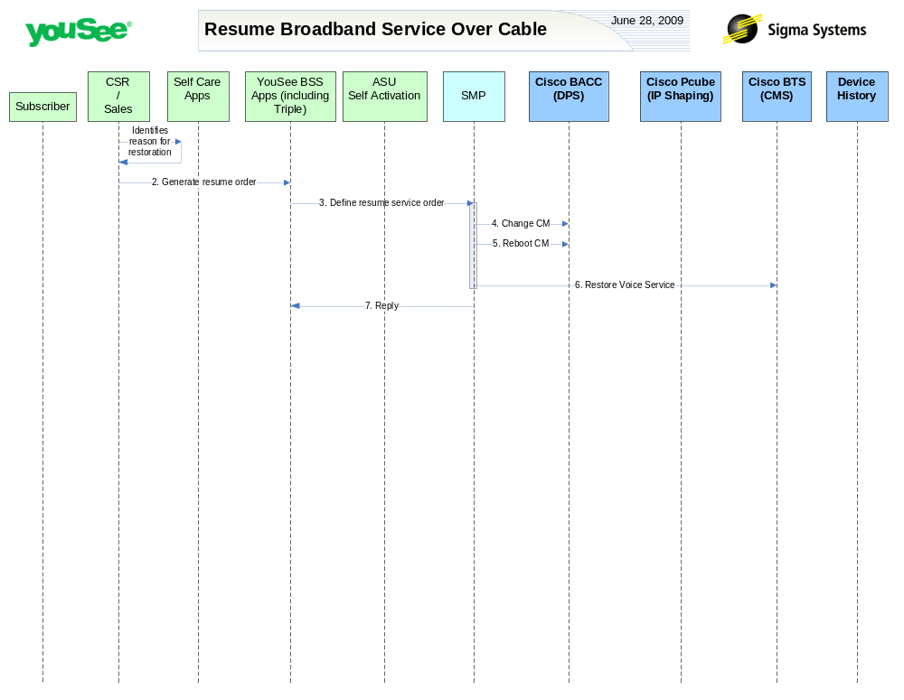

Primary Flow Detail
# | Actor: Key Action | Description | Alternate Flows/Details
 | CSR: Identifies reason to resume subscriber’s broadband service | A YouSee employee or business process identifies a reason to resume a previously suspended service.  This may be because the customer has paid a past due account, returned from vacation or complied with terms of use notification. These reasons are out of the scope of this document
 | CSR: Order is created in YouSee BSS applications | <As in Change service Order>
 | YouSee BSS: Order is communicated to SMP | <As in Change service Order>
 | SMP: modifies CM in BACC | SMP will change the configuration of the CM in BACC resulting in restoration of internet traffic.  SMP will change the Product associated with Subscriber and will restore it to the Product prior to Suspension.  This will be handled in Triple as change of Product.
 | SMP: requests BACC to reboot the CM Device | Device is rebooted resulting in it receiving the new configuration
 | SMP: resumes the voice service in BTS | SMP will modify the configuration of the voice service in the BTS to restore full voice functionality.  SMP will change the cos-restrict-id on CISCO BTS. SMP should restore the cos-restrict-id to the value prior to Suspension.  This will be handled in Triple as change of Product.
 | SMP: Replies back to Triple the status of Activation | SMP will reply to ASU the status of Provisioning Order to ASU. | If Provisioning fails then SMP will put the Failed task in Manual Queue.

